**Volumes:**

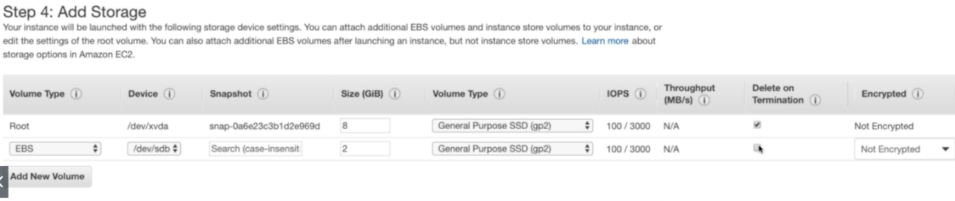

* By default, there will be a root volume while creating an EC2 instance. We can add EBS volumes as above while creating the EC2 instance.
* We cannot remove the root volume. It gets added based on the instance type we are creating.

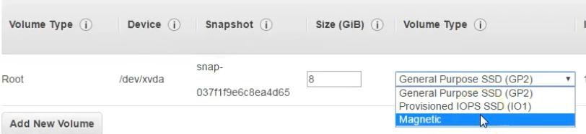

* We can only see three types of volumes. We also got another two types of HDDs, but it won’t appear here because that cannot be added to the primary/root volume.
* The device type of the root volume is **“/dev/xvda”** as above. It changes based on the server or OS. We can use same type if we want to add any root volume to the instance.

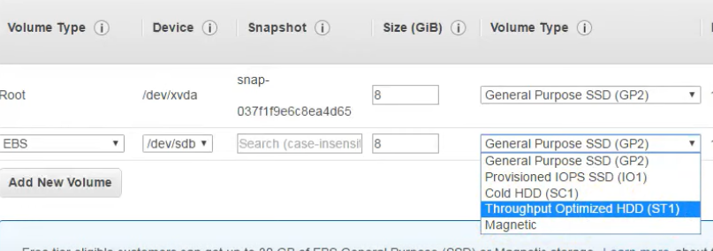

* But we can add it to the secondary volume as above.

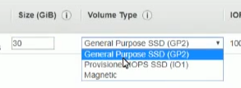

* We can see there are 3 types of volume types while creating EC2 instance
* IOPS means the input output per second
* We can have multiple volumes associated with the server

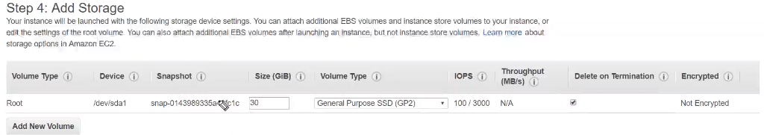

* As above, device means the name which it will displays inside the server.
* And IOPS is 100 means we can read/write 100 times per second and it can reach upto 3000. But 100 is guaranteed
* For general purpose volume, we get 3 IOPS per GB with minimum 100 IOPS, burstable to 3000 IOPS as above
* SSD means Solid State Drives
* Delete on termination will delete the volume once we terminate the instance
* By default, it is not encrypted
* Another one is provisioning IOPS SSD. This is where we can give how many IOPS we want. We can give 10000 IOPS if we want
* Provisioned IOPS SSD is the most expensive and highly performing hard disk

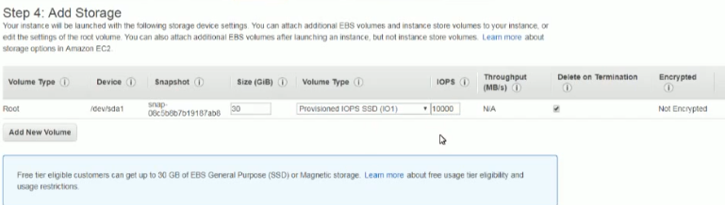

* We can also go for magnetic type which doesn’t have IOPS
* We use this to store old kind of data which doesn’t require IOPS
* Magnetic is the traditional one this we use in desktops. There are no IOPS guaranteed in that. And these are not much fast and very cheap in cost

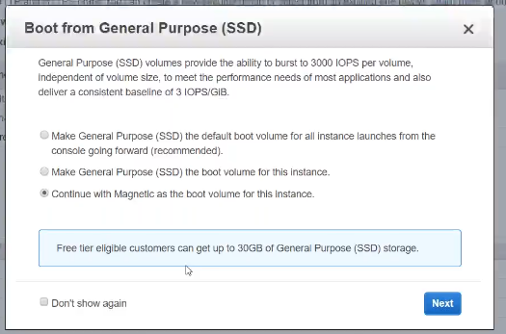

* Volume should be in same availability zone where the servers is

**Creating & attaching volume:**

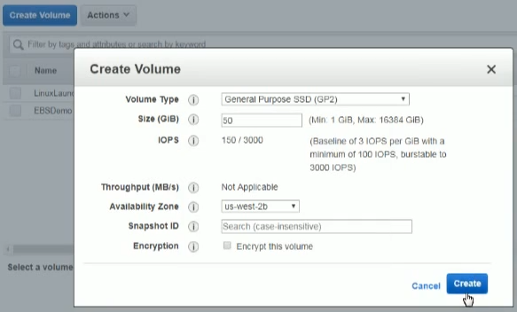

* We can create the volume as above even separately after creating the EC2 instance.

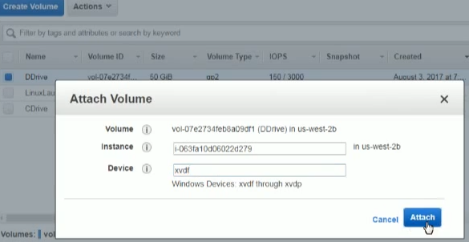

* We can click on actions and attach the volume to instance
* We can’t detach it if the attached instance is running.
* We can also add the volumes as root with the device type as below.

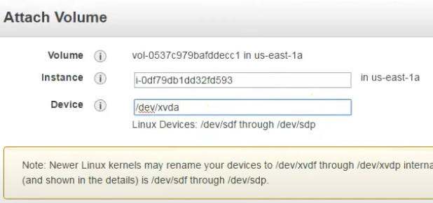

* This device type, we can get while creating the instance.

**Detach volume:**

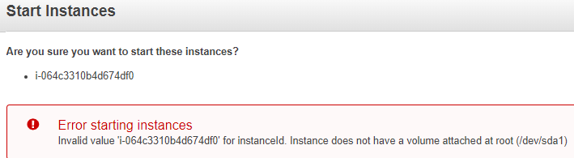

**Above is the error after detaching the root volume and we are unable to start the instance without root volume**

